Financial Data User Group Meeting - Summary
November 29, 2011, Noon
Terrace Room, Claudia Cohen Hall
- Warehouse Website Enhancements: Coming in December to the Data Warehouse website – enhanced navigation to data collection documentation, as well as resources for building queries and working with reports. Changes will include:
  - Left and right-hand navigation reordered and expanded for ease of access
  - New top menu bar contains information about accessing and using the Warehouse, regardless of collection
  - Data collection sites now include quick reference and scenario links
  - Self-directed learning options include data collection training modules for General Ledger, Salary Management and PennERA Proposals collections, already available on Knowledge Link.

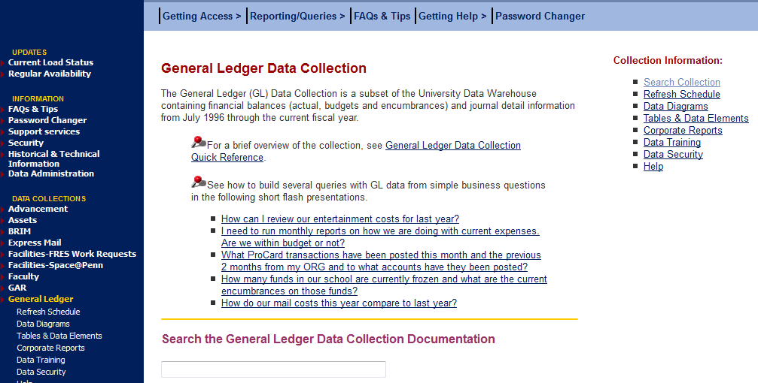

- InfoView/Webi - Show & Tell: Glen Lafferty, from the Department of Medicine (DMED), presented the latest results of a DMED working group/SOM ORSS and ISC collaboration on revisions to the GRANT REPORTS – PI Awarded report tailored to present information specifically relevant to PIs. The latest version of the report is available in InfoView, in the Schools and Centers/Schools/Perelman School of Medicine/Dept of Medicine folder. Keep in mind that this report is still a work in progress and may change as the Department of Medicine needs develop. A couple additional points of note about the report:
  - NIH object rollups: The report is using a new table that maps object codes to NIH groupings. The “NIH Object Category” is available in both FINQUERY and RSALMGT for your use:
    - FINQUERY: Located in the Support Objects for Canned Queries folder, at the bottom of the query panel list, and can be used with either Balances or GL Detail to COA Objects. (You’ll likely be prompted to select the appropriate universe context.)
    - RSALMGT: Located in the Support Objects folder, at the bottom of the query panel list. Contains separate NIH Object Category objects for payments (EP) and encumbrances (EE).
  - View as PDF for easy printing: Using InfoView’s View as PDF mode, you can navigate within the report results to select specific pages for printing. See this FAQ for tips - http://www.upenn.edu/computing/da/bo/webi/qna/iv_printing.html.
  - Make a shortcut: Remember that you can make a shortcut to this and other repository reports so you always use the latest version. For more on shortcuts vs copying reports, see this FAQ: How do I create a shortcut to a corporate report and why not just copy the report?
- InfoView/Webi – Tips and Tricks
  - BusinessObjects, InfoView, and Webi – what’s the difference and where am I? SAP BusinessObjects is Penn’s supported query tool for the Warehouse. It is a software suite that includes various components, including:
    - InfoView, which is the portal to all BusinessObjects reports. You log into InfoView to access BusinessObjects, and are always working within it, even when you launch Webi. When refreshing reports in InfoView, you can use its interactive features to (re-)arrange results on report tabs, add/edit filters, breaks and sorts, and work with variables. InfoView provides access to:
      - the individual's personal collection of queries and reports, stored in their My Favorites area on the server
      - the Public Folders which contain all reports shared by groups of people
      - the gateway to Web Intelligence, either by choosing the option to edit an existing Webi report, or selecting New, and then Web Intelligence Document from one of the dropdowns in the toolbar.
    - Web Intelligence (Webi) is used to
      - create new queries
      - edit existing queries
      - work with additional features such as linking providers, report alerts and ranking, etc.
  - Filters, filters, everywhere! With the migration to InfoView and Webi, users now have much greater flexibility in filtering report results. With this opportunity comes some confusion, as “filters” refer to a variety of features. See these FAQs for clarification on your filtering options:
    - What's a "filter" and why should I use one (or several)?
    - How can I add a report filter in InfoView?
    - How can I see and work with all of the filters applied on a report at once?
  - FINQUERY context prompts (Balances vs GL Detail): When running queries – including some repository reports, like fundsummary, GRANT REPORTS and others -- in FINQUERY, you may see a context box pop up, prompting you to select Balances or GL Detail. This appears because all of the reference tables (e.g., ORG Codes, Fund Codes, etc) are joined in the universe to both the Balances and GL Detail tables, and Balances and GL Detail should never be used together. Just think for a moment about whether you wish to retrieve account balance (Balances) or journal detail (GL Detail) information, and select the appropriate option – is almost all cases, the answer is Balances. If your report contains multiple queries, the box may appear for each one.
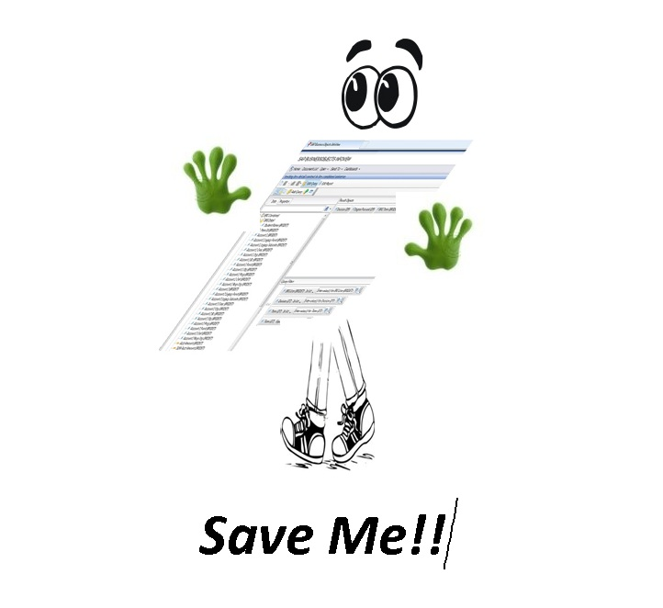
  - Timeouts: BusinessObjects will time out your session for security and performance reasons. Some best practices to keep in mind:
    - Use InfoView and interactive viewing unless you need to edit the query itself in Webi
    - Save Often!
    - See this FAQ: Working with Timeouts in Webi

- Combining queries: BusinessObjects provides a few options for combining results from queries in one report file – ranging from having the data on separate report tabs to using the results together in one table. The FINQUERY – Year over Year Comparison report in the General Ledger folder is one example of this, with two linked queries to retrieve balances from different points in time, and then using variables to calculate the variance. The October Student user group presentation (slides 13-19) describes some other options – we’ll review these in future FAQs or sessions.

- Travel & Expense (TEM) reporting: Concur, the new TEM system is coming in 2012; evaluation of potential system reports and data available is getting underway. At the 11/29/2011 user group meeting, attendees discussed their hopes for reporting and analysis of TEM data once it’s available, including:
  - Where have people been? Why did they go there? What did it cost?
    - Facilitate Aggregate travel expenses by conference. (How many people went to Ivy Plus this year? How much did it cost?)
    - International travel by country
    - Track travel dates
  - Grant related:
    - Identify travel expenses charged to 5- funds by people who are not paid from 5- funds
    - Tie travel detail to grant reporting; show travel detail on the grant detail report
    - Travel expense incurred near the end of the life of a fund
  - Ability to identify, report on/summarize by travel reasons (recruitment, conference, research, etc.), including any free-form comments
  - Tie advances to reimbursements to calculate total spent on trip
  - Report on the bundle of all pre-approved expenses together (air fare, conference registration fees, advances, etc.)
  - Visibility into per diems and exchange ranges (at the time of the trip)

- Monitoring PennWorks/Payroll distributions: If you’re responsible for managing Payroll and distributions and haven’t seen these already, you might be interested in the following RSALMGT universe reports (available in the Payroll/Salary Management folder in InfoView) to help in monitoring distributions:
  - Distributions Ending Review: PennWorks/Payroll distributions ending during a given date range.
  - Distributions vs Pay End Date: review whether distributions are active for employees as of the desired pay period end date.
  - Distributions Review: any PennWorks final/projected distributions and those currently in Payroll
You can also add the Current Dist Indicator (available in the Employee General class folder in RSALMGT) to quickly see (Y/N) whether there are any current distributions for the employee. This value is recalculated nightly, based on distribution start/end date relative to the date on which the nightly jobstream began.

